|  |  |  |  |
| --- | --- | --- | --- |
|  | 5/22/2015 |  | |
|  | |  | |
| Git and Git HUB usage guide  *User Manual* | | | |
|  |  | |  |
|  |  | | Sreerekha Deb |

# 1.Introduction

GIT is the modern open source distributes version control system which is in use in the current IT industry. It has predecessors like CVS, SVN and the likes in the industry.

The version control system needs to have the following features .

1. Allow the developers to create a repository to keep their code in a controlled environment .
2. It is particularly important in a team environment where the developers working on various chunks of code can share the code across geographies .
3. A very disciplined mechanism to control the releases of code and there can be a role mechanism in place to control the access rights on the code for the developers .
4. For example : only the team lead can have the right to delete code , or no one can delete code .The developers can only check in and check out the code assigned to them .
5. The features like code compare with highlighting of the text where the code was changed and also a whole history of the commits done and the access to older versions are supported like in any standard version control systems

# 2.What is GIT

Git is a version control system which can be installed on your workstation or on a server . You can download the software from the following URL <https://git-scm.com/> .

## 2.1 Installation and use

After you have installed the version control system on your machine you can open the command prompt and check but typing git on the command prompt , then it should chow you all the options of the git usage.

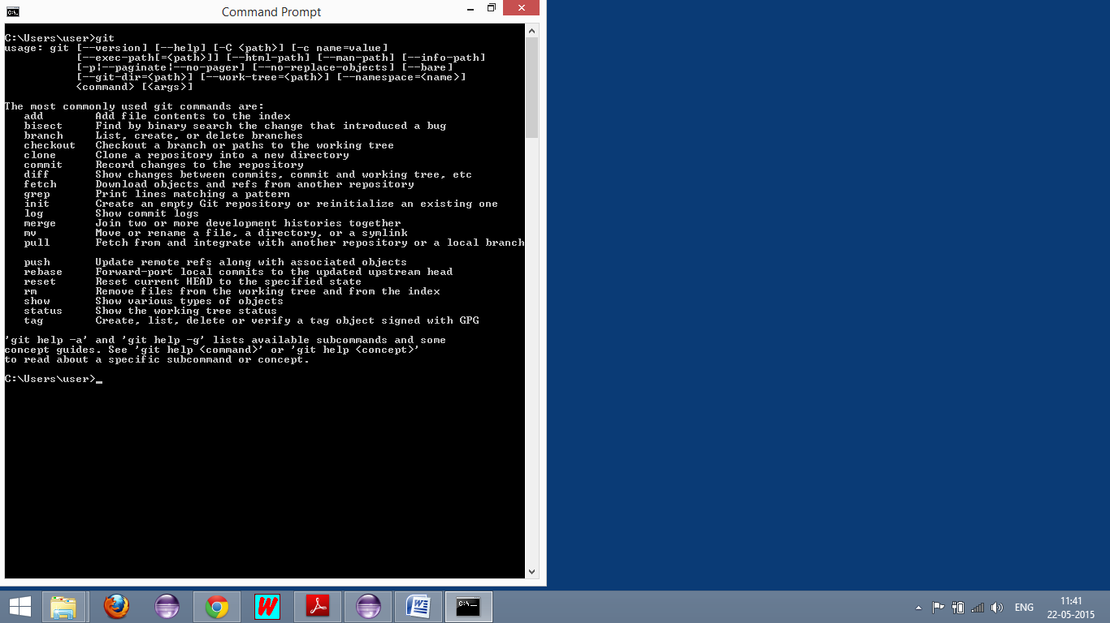

# 3.What is GIT HUB

GIT HUB is the online free distributed space for creating and managing your GIT repositories.

## 3.1.User id creation screen shots

# 

Visit the URL <http://www.github.com> and click on the Sign up link.

Pick the user name and the password and sign up for GITHUB.

## 3.2 Login Page

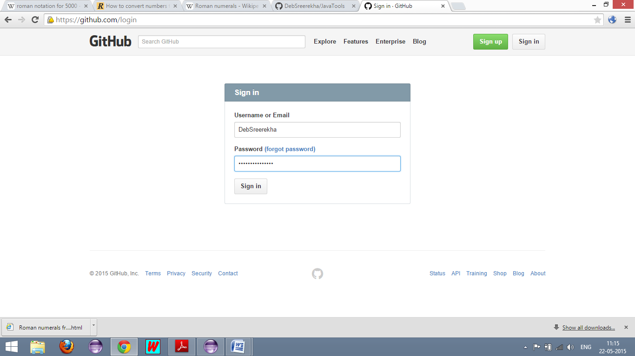

## 3.3. Landing Page

# 

## 3.4. Create repositories

You can create new repositories with the suggested link on the screen and start checking and checking out code with either the command prompt controls or via eclipse ide plugins.

# 4. Usage via eclipse IDE.

## 4.1 Setting up the local repository

Browse to the project folder which needs to be put in git . To mark the working directory as the git local repository you will need to right click on the project and select NEW-> Other -> Git-> GitRepository->Next->

Enter the location of the folder where you wish to create the working directory .. then click on enter .

If you choose the current eclipse directory as the working directory then the same folder will be your local respository else whichever directory you choose as the working directory the code will be moved to that folder .

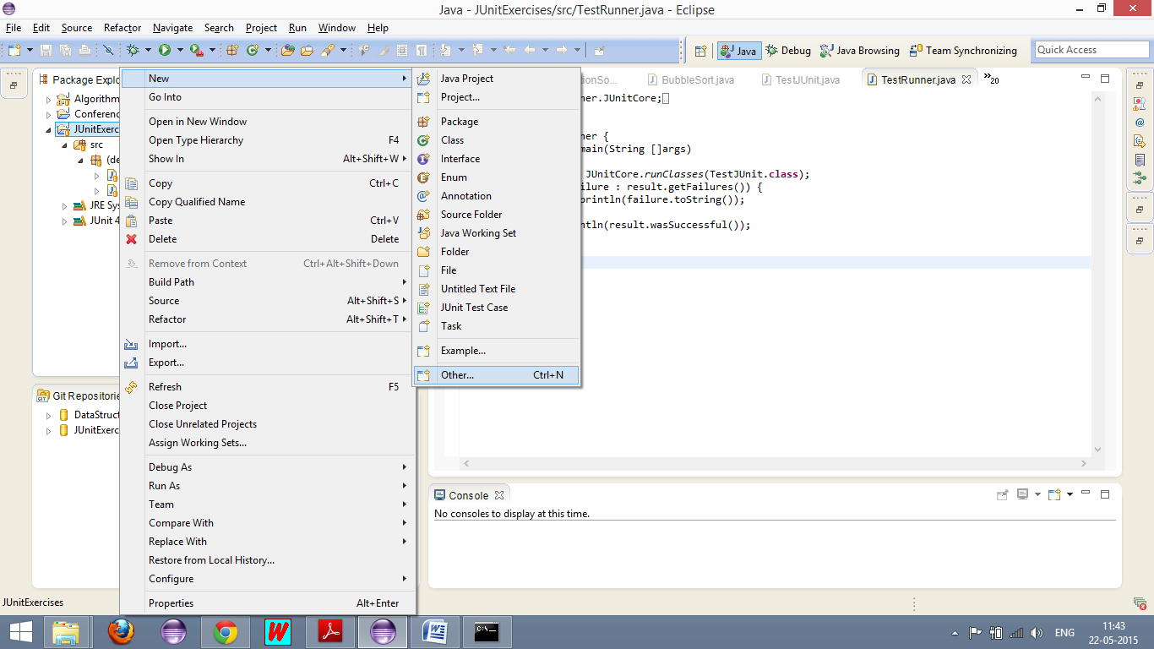

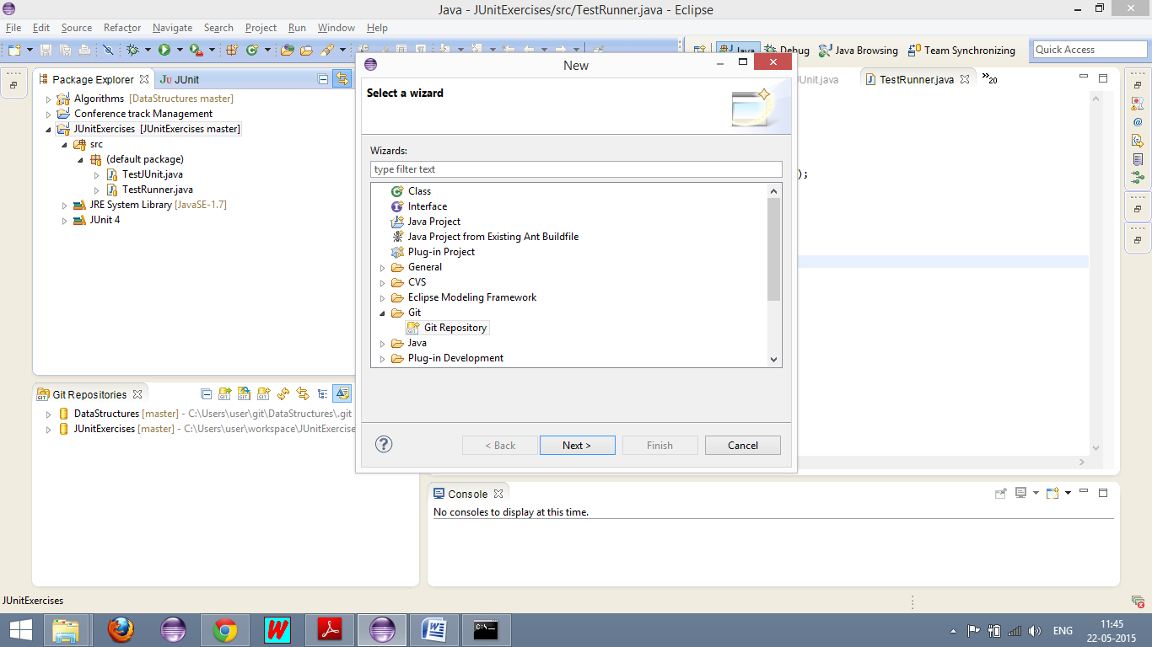

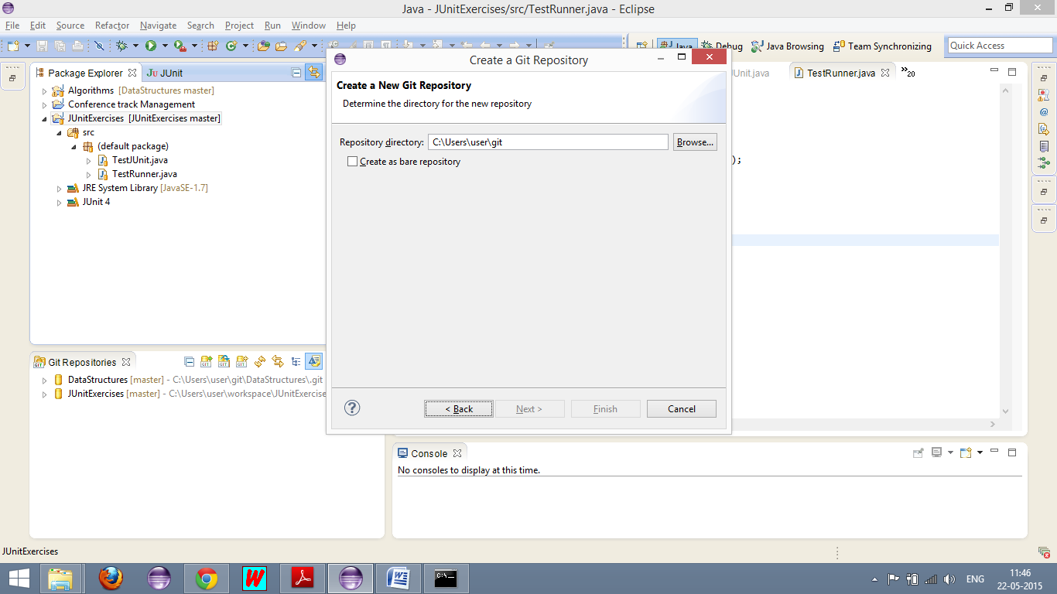

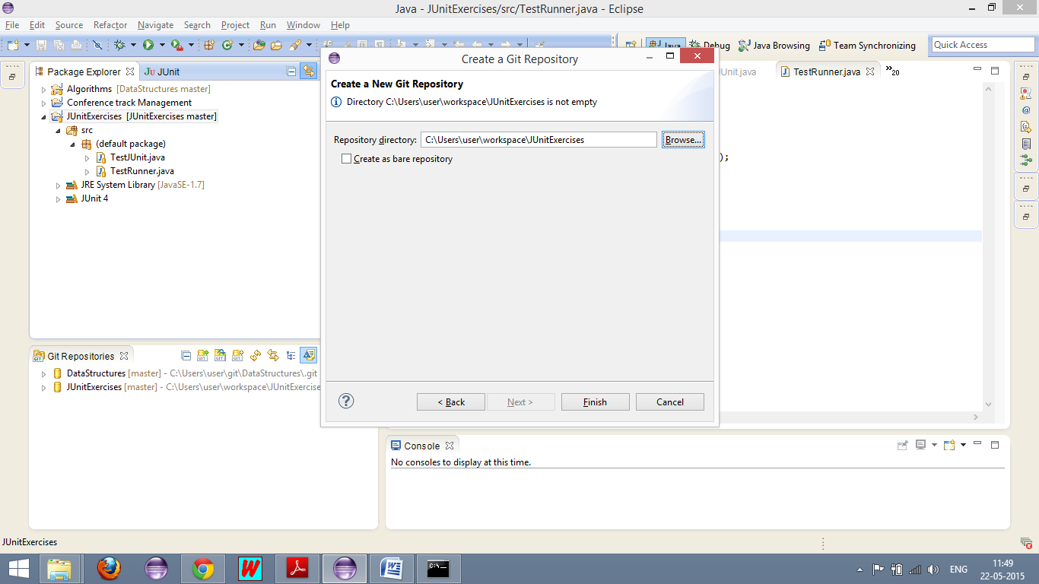

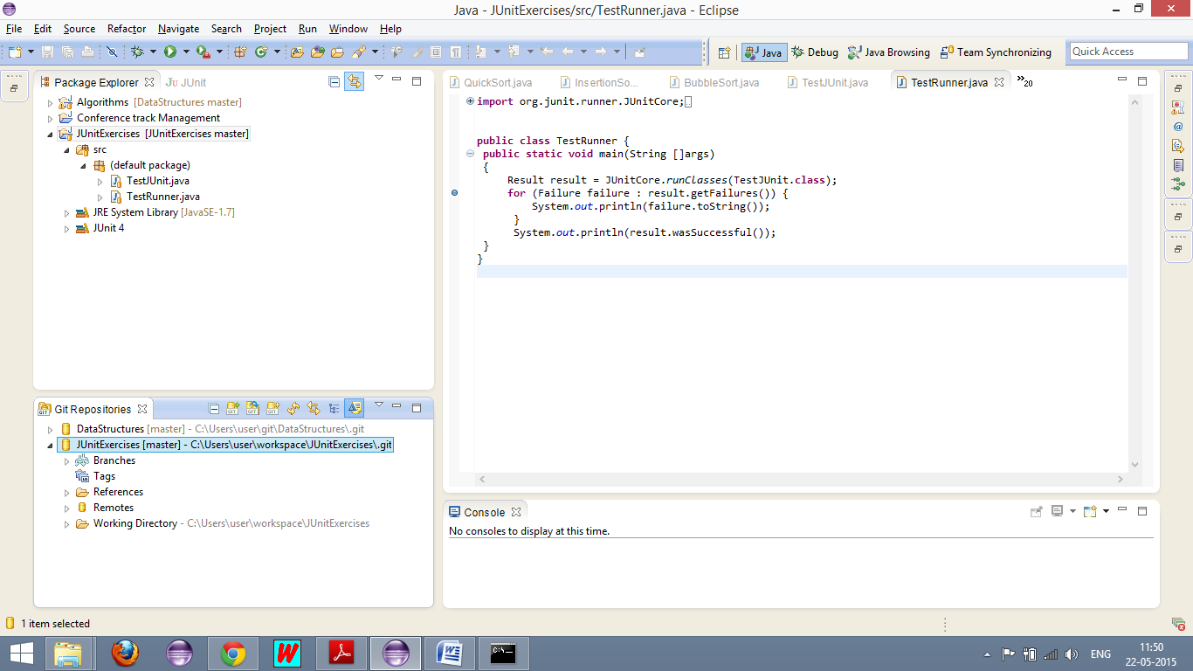

## 4.2 Setting up the remote server settings from the GIT repositories view .

After you have set the local repository if you click on the Remote folder in the current respositories view , you will be required to set the remote sever fetch and push URIs..

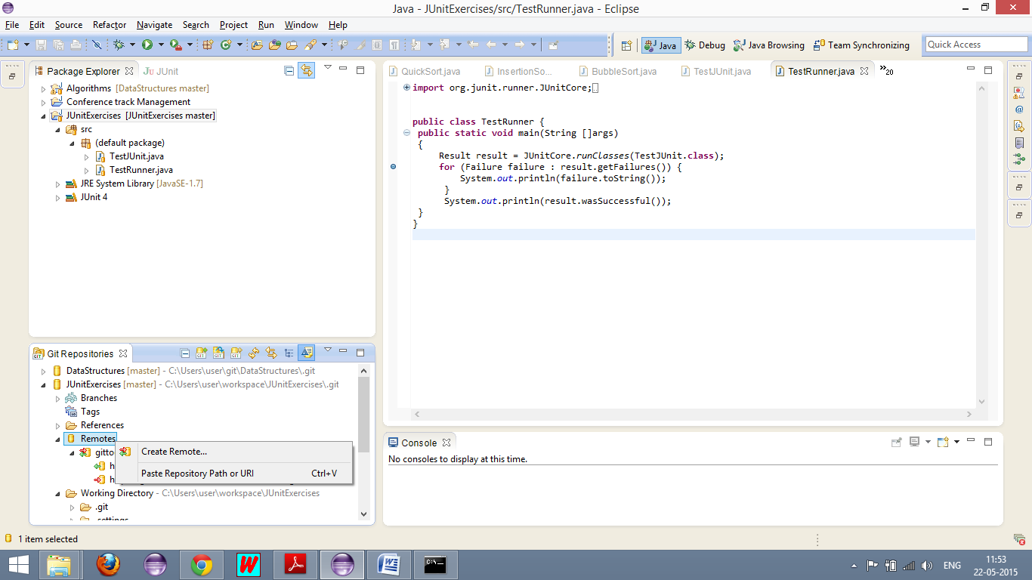

Once you do this you can directly commit and push the code and fetch the code from the git Hub to your eclipse IDE and Vice versa.

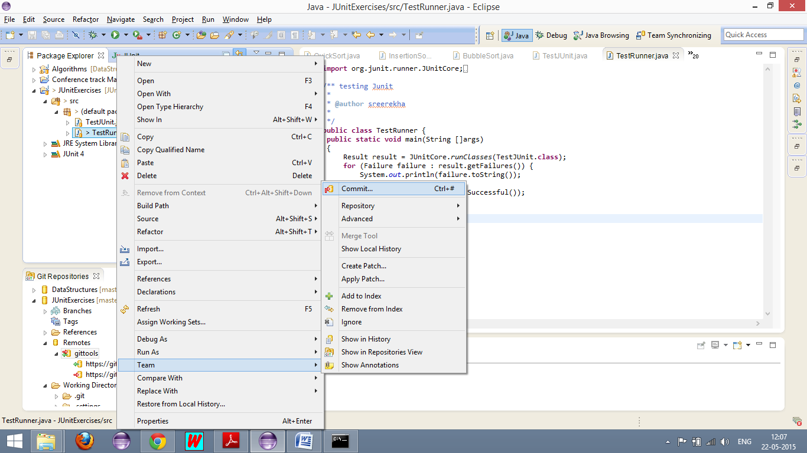

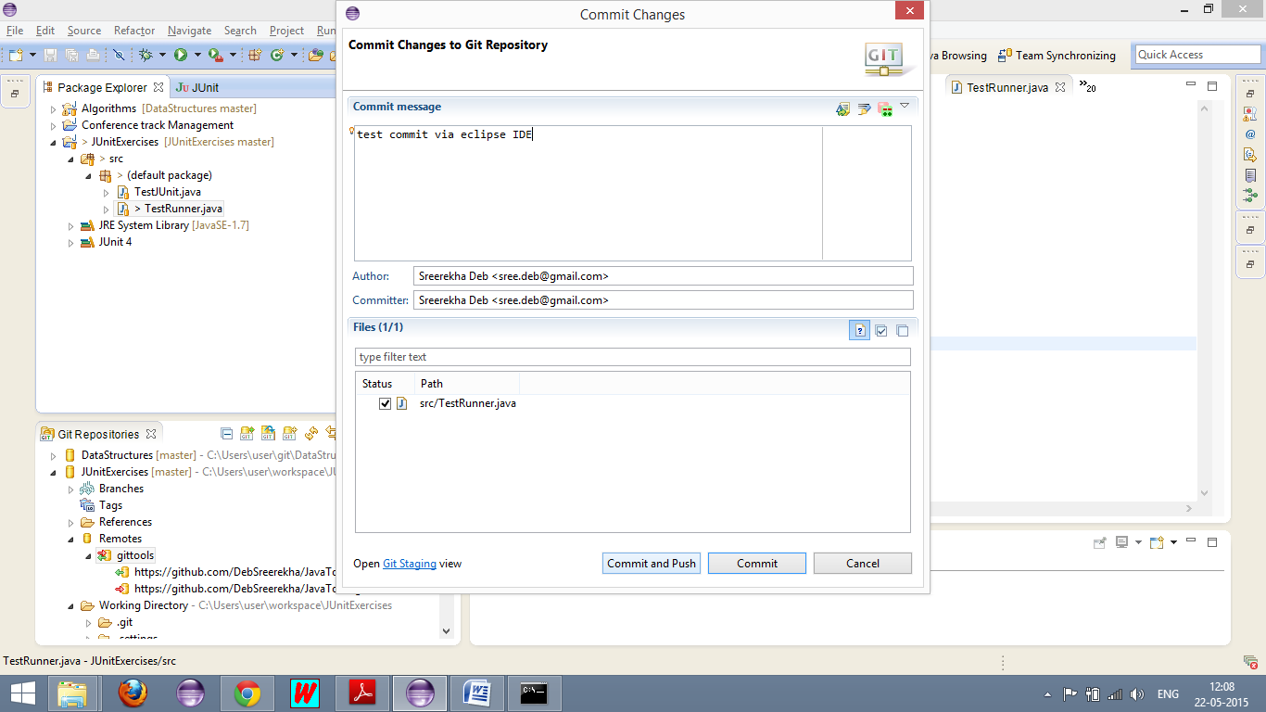

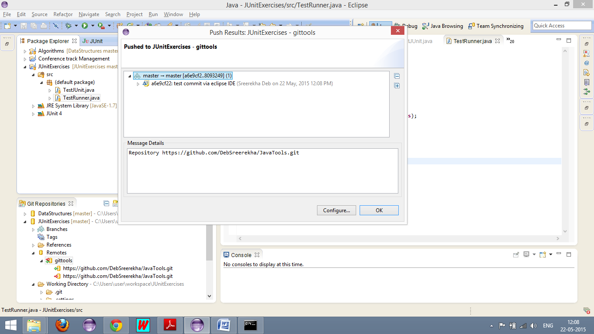

Your code is now pushed to the GITHUB repository .

